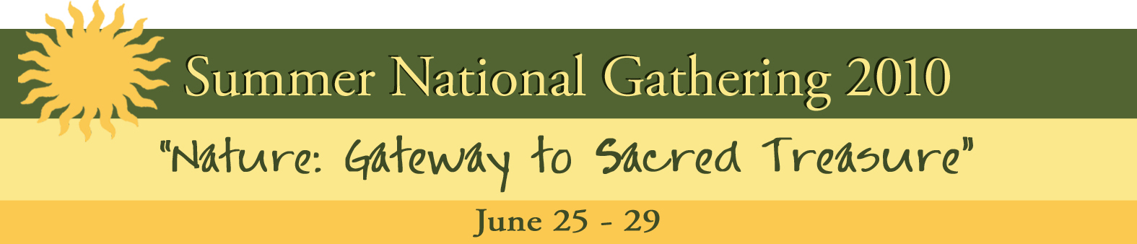

FRIDAY, June 25

1:00–2:00 Discussion Group Leaders’ Orientation
2:00–3:30 TOS Members meeting
2:00–5:00 Registration (Lobby)
4:00 Guided walking tour of the grounds and buildings (start in Lobby)
Meeting for ES members
5:30 Supper (Nicholson Hall)
7:30 Opening of the 124th Annual Meeting (formal wear optional): Invocation, Prayers of the
Religions, Welcoming, Introductions, Greetings from international and local groups,
Credentials Committee report, and Announcements
8.30 Unveiling of Burton Callicott’s painting: Mandorla #12 (Oil on linen, 1989)
8:45–9:45 Violin Recital with Dr. Cármelo de los Santos
Ribbon Cutting and Refreshments (Nicholson Hall)

SATURDAY, June 26

7:00 Yoga
7:30–8:00 Breakfast (Nicholson Hall)
8:45–9:00 Meditation
9:15–10:15 Public Lecture ─ The Golden Section: Nature’s Greatest Secret by Dr. Scott Olsen
10:45–11:45 Discussion Groups
12:00 Lunch (Nicholson Hall)
1:00–2:00 Meditation Lecture – Lost: Reflections on a Poem of Counsel by Maria Parisen
3:00-3:30 Milwaukee Lodge Centennial Celebration
3:30–4:30 Public Lecture ─ Journey into Beauty: How Nature Supports our Every Step by Kathy Gann
4:30–5:00 Discussion Groups
5:30 Supper (Nicholson Hall)
7:00 The Theory of Everything - Opera Reading by Nancy Rhodes, Artistic Director of Encompass New Opera Theatre in New York City
Social gathering (Nicholson Hall)

SUNDAY, June 27

7:00 Yoga
7:45–8:30 Breakfast
8:45–9:00 Meditation
9:15- 12:00 Activity Reports / Business meeting ─ all invited
12:00 Lunch
1:30–2:30 Public Talk – Bridge over Treasured Waters: Mathematics, Metaphor, and the Weird and Wonderful Gap between Thing and No Thing by Jonathan Zimmer, M.A.
2:30–3:00 Break
3:00–4:00 Discussion Groups
4:15-5:15 Public Lecture – Yoga psychology and the transformation of emotions by Dr. Uma Krishnamurthy
5:30 Supper
6:15-6:45 Round Table – Flower Ceremony
7:1 7:15 Fun night
Social gathering (Nicholson Hall)

MONDAY, June 28

7:00 Yoga
7:45–8:30 Breakfast
8:45–9:00 Meditation
9:15–10:15 Members Talk – Sacred Science: Ancient Wisdom or Modern Fad by Dr. Ralph Hannon
10:45–11:45 Discussion Groups
12:00 Lunch
2:00-3:30 The Quantum Activist, a new documentary by Dr. Amit Goswami, a pioneer of this
revolutionary new perspective within science, shares with us his vision of the unlimited potential
of consciousness as the ground of all being, and how this revelation can actually help us to live
better. (77 min)
4:00–4:30 Questions and Answers – Dr. Amit Goswami
4:30-5:30 Book Signing by Dr. Amit Goswami (25% off regular price)
5:30 Supper
7:00 Premier DVD showing: 2010 Update: The Mahatmas and their Letters – a complete remake of the original 1989 program including new material and appearances by a number of Theosophical leaders and scholars including Ed Abdill, Ianthe Hoskins, and Joy Mills.

TUESDAY, June 29

7:00 Yoga
7:45–8:30 Breakfast
8:45–9:00 Meditation
9:15–10:15 Members Talk – Why am I a Theosophist? by Dan Noga
10:45–11:45 Panel Discussion – Dr. Amit Goswami, Dr. Scott Olsen, Jonathan Zimmer, M.A.,
and Dr. Uma Krishnamurthy
11:45 Closing: Betty Bland, TSA President
12:00 Lunch
1:00 Socializing and leave-taking

Meals and refreshments in the Nicholson Hall; all meetings in the Auditorium, except as indicated.
Bargain Book Sale at Quest Book Shop throughout the Conference
***Archival Display and Art Exhibit during the entire conference***

